**1. Build a RESTful API using MongoDB.**

**Index.js -**

// Import express

let express = require("express");

// Import Body parser

let bodyParser = require("body-parser");

// Import Mongoose

let mongoose = require("mongoose");

// Initialise the app

let app = express();

// Import routes

let apiRoutes = require("./api-routes");

// Configure bodyparser to handle post requests

app.use(

bodyParser.urlencoded({

extended: true,

})

);

app.use(bodyParser.json());

// Connect to Mongoose and set connection variable

mongoose.connect("mongodb://localhost/student", { useNewUrlParser: true,

family: 4, });

var db = mongoose.connection;

// Added check for DB connection

if (!db) console.log("Error connecting db");

else console.log("Db connected successfully");

// Setup server port

var port = process.env.PORT || 8080;

// Send message for default URL

app.get("/", (req, res) => res.send("Hello World with Express"));

// Use Api routes in the App

app.use("/api", apiRoutes);

// Launch app to listen to specific port

app.listen(port, function () {

console.log("Running RestHub on port " + port);

});

**contactModel.js -**

var mongoose = require("mongoose"); // Setup schema

var contactSchema = mongoose.Schema({

name: {

type: String,

required: true,

},

email: {

type: String,

required: true,

},

gender: String,

phone: String,

create_date: {

type: Date,

default: Date.now,

},

}); // Export Contact model

var Contact = (module.exports = mongoose.model("contact", contactSchema));

module.exports.get = function (callback, limit) {

Contact.find(callback).limit(limit);

};

**contactController.js -**

// contactController.js

// Import contact model

Contact = require("./contactModel"); // Handle index actions

exports.index = function (req, res) {

Contact.get(function (err, contacts) {

if (err) {

res.json({

status: "error",

message: err,

});

}

res.json({

status: "success",

message: "Contacts retrieved successfully",

data: contacts,

});

});

}; // Handle create contact actions

exports.new = function (req, res) {

var contact = new Contact();

contact.name = req.body.name ? req.body.name : contact.name;

contact.gender = req.body.gender;

contact.email = req.body.email;

contact.phone = req.body.phone; // save the contact and check for errors

contact.save(function (err) {

if (err) res.json(err);

res.json({

message: "New contact created!",

data: contact,

});

});

}; // Handle view contact info

exports.view = function (req, res) {

Contact.findById(req.params.contact_id, function (err, contact) {

if (err) res.send(err);

res.json({

message: "Contact details loading..",

data: contact,

});

});

}; // Handle update contact info

exports.update = function (req, res) {

Contact.findById(req.params.contact_id, function (err, contact) {

if (err) res.send(err);

contact.name = req.body.name ? req.body.name : contact.name;

contact.gender = req.body.gender;

contact.email = req.body.email;

contact.phone = req.body.phone; // save the contact and check for errors

contact.save(function (err) {

if (err) res.json(err);

res.json({

message: "Contact Info updated",

data: contact,

});

});

});

}; // Handle delete contact

exports.delete = function (req, res) {

Contact.remove(

{

_id: req.params.contact_id,

},

function (err, contact) {

if (err) res.send(err);

res.json({

status: "success",

message: "Contact deleted",

});

}

);

};

**api-routes.js-**

// api-routes.js// Initialize express router

let router = require("express").Router(); // Set default API response

router.get("/", function (req, res) {

res.json({

status: "API Its Working",

message: "Welcome to RESTHub crafted with love!",

});

}); // Import contact controller

var contactController = require("./contactController"); // Contact routes

router

.route("/contacts")

.get(contactController.index)

.post(contactController.new);

router

.route("/contacts/:contact_id")

.get(contactController.view)

.patch(contactController.update)

.put(contactController.update)

.delete(contactController.delete); // Export API routes

module.exports = router;

1. GET -

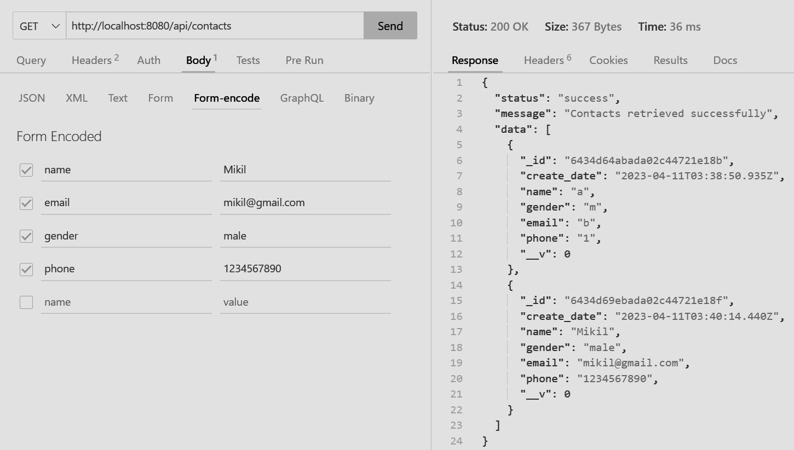

1. PUT -

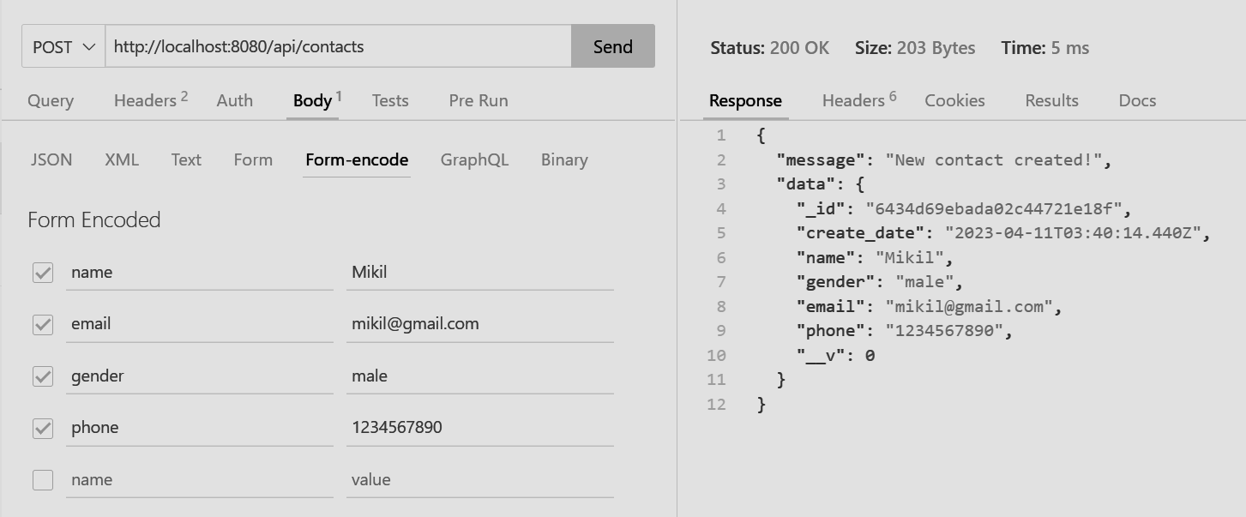

1. PUSH -

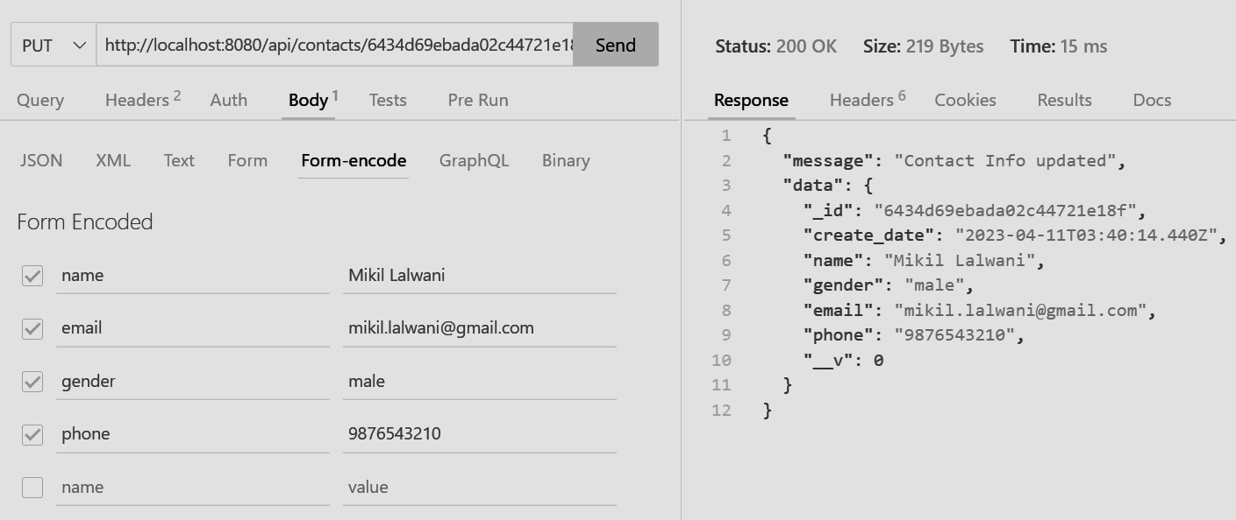

1. DELETE -

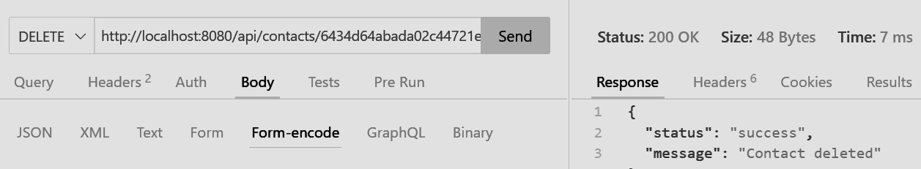

**2. Create a new database to store student details and perform the following on the database.**

1. **Create a database.**
2. **Create a collection.**
3. **Create a document and insert one document and insert many documents at once.**
4. **Search with conditions.**
5. **Change the roll no of a student**
6. **Delete one or many documents**
7. Create a database.

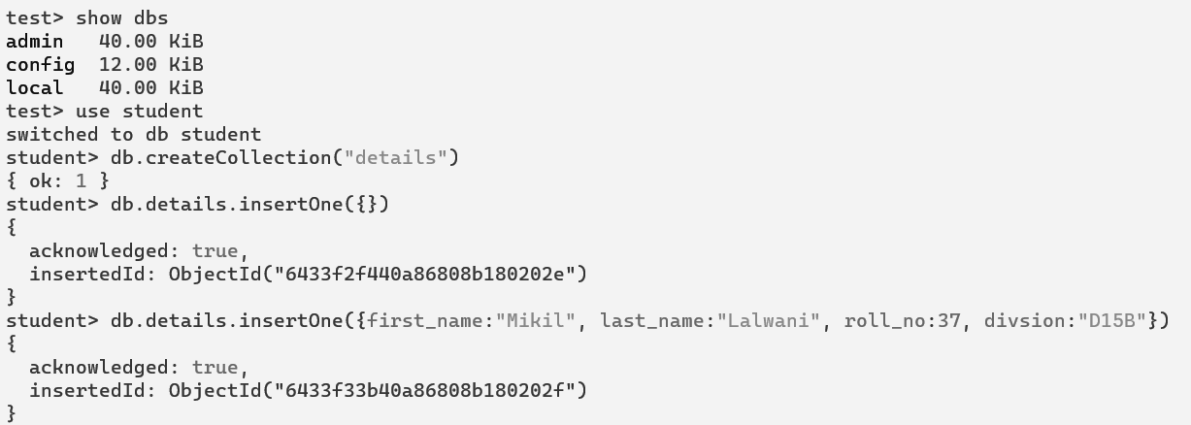

1. Create a collection.



1. Insert one document.



1. Insert many documents at once.

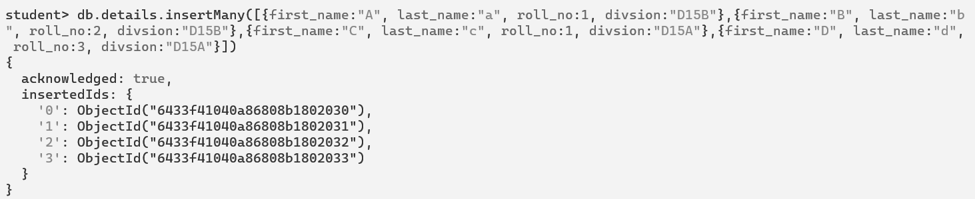

1. Find all documents.

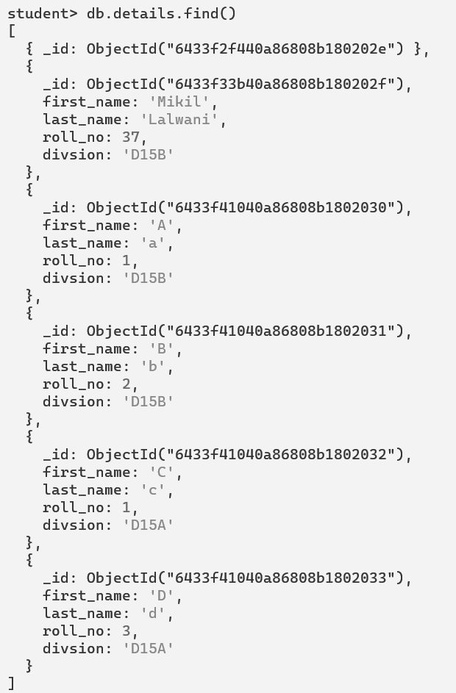

1. Find documents using conditions.

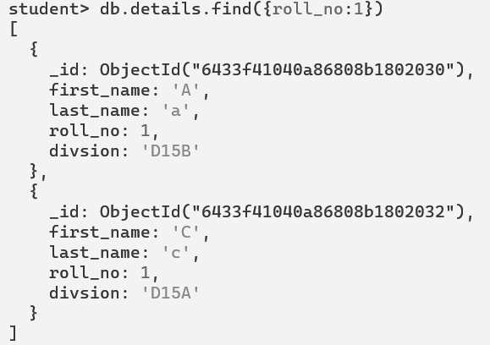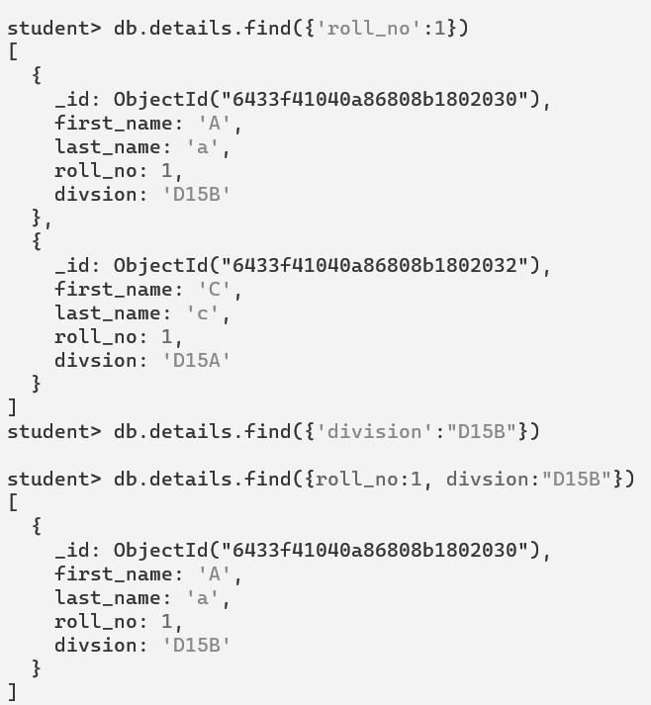

1. Delete one document.

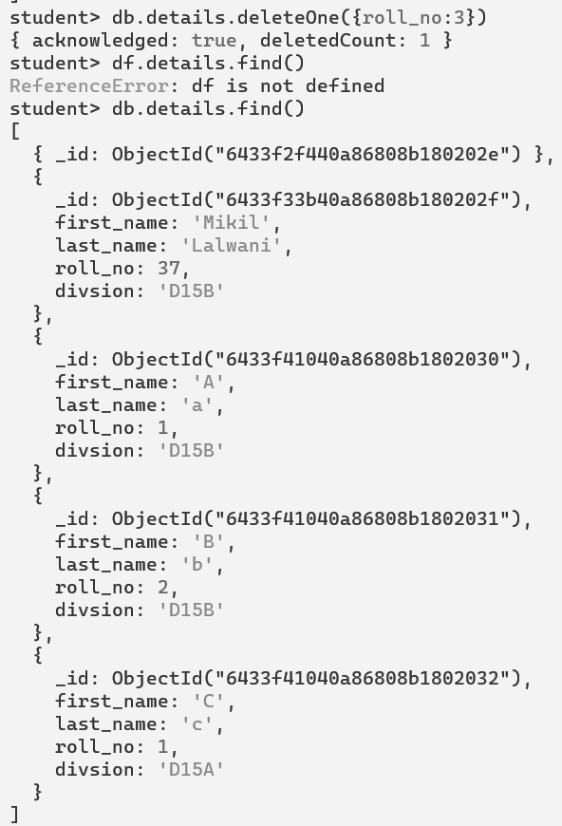



1. Delete many documents at once.

